**DAILY ONLINE ACTIVITIES SUMMARY**

|  |  |  |  |  |  |  |  |  |
| --- | --- | --- | --- | --- | --- | --- | --- | --- |
| **Date:** | **30/05/2020** | | | | | **Name:** | **POOJA D S** | |
| **Sem & Sec** | **4th SEM 'B' Section** | | | | | **USN:** | **4AL18CS056** | |
| **Online Test Summary** | | | | | | | | |
| **Subject** | | **1.Data Communication**  **2.Complex Analysis, Probability and Statistical Methods** | | | | | | |
| **Max. Marks** | | **1.30**  **2.30** | | **Score** | | | **1.24**  **2.20** | |
| **Certification Course Summary** | | | | | | | | |
| **Course** | **Introduction to Digital Marketing** | | | | | | | |
| **Certificate Provider** | | | **Great Learning Academy** | | **Duration** | | | **5 hour** |
| **Coding Challenges** | | | | | | | | |
| **Problem Statement:** A user will input two strings, and we find if one of the strings is a sub sequence of the other. Program prints “yes” if either the first string is a sub sequence of the second string or the second string is a sub sequence of the first string. Assume that, the length of the first string is smaller than or equal to the length of the second string. Assume that, the length of the first string is smaller than or equal to the length of the second string. | | | | | | | | |
| **Status: completed** | | | | | | | | |
| **Uploaded the report in Github** | | | | | **yes** | | | |
| **If yes Repository name** | | | | | <https://github.com/dspooja/C-coding> | | | |
| **Uploaded the report in slack** | | | | | **yes** | | | |

Online Test Details: (Attach the snapshot and briefly write the report for the same)

Certification Course Details: (Attach the snapshot and briefly write the report for the same)

Coding Challenges Details: (Attach the snapshot and briefly write the report for the same)

ONLINE TEST DETAILS:

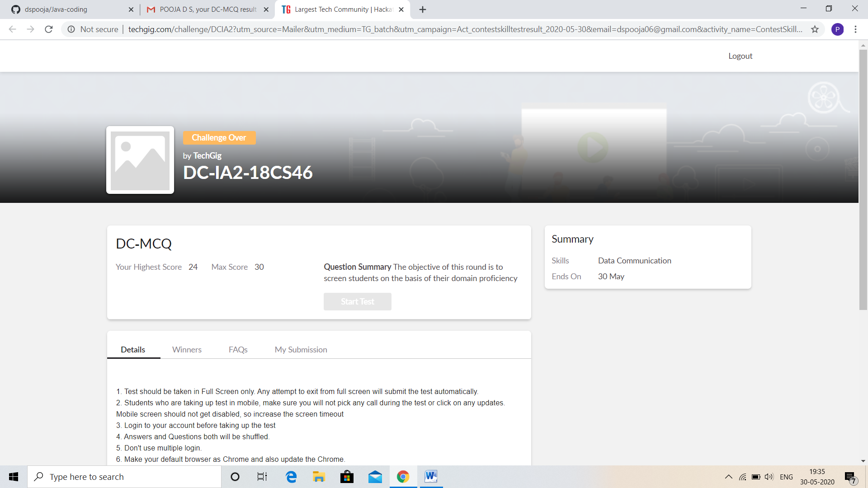

CERTIFICATION COURSE DETAILS:

* As continuation of the **Introduction to Digital Marketing online course.**
* **The concepts covered in Introduction to Digital Marketing are:**
* Explanation of New Medias
* Understanding Brand Purpose
* Introduction to Facebook Marketing
* Purpose of using Facebook as Marketing Channel
* Facebook Interface and Types of Audiences

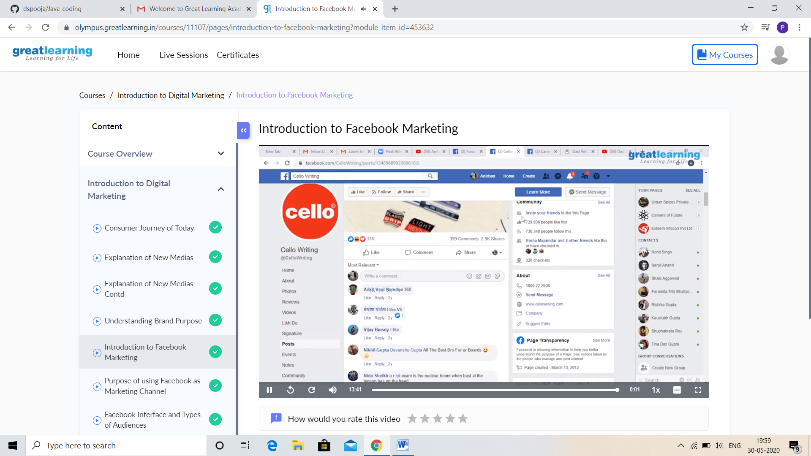

CODING CHALLENGES DETAILS:

Problem statement 1:

Write a C Program to count Uppercase, Lowercase, special character and numeric values for a given String

**Input :** Read a String (combination of character, numeric, special character)from keyboard.  
**Ex:#HaaGs01fOr@haaks07**  
**Output:**  
Upper case letters:5  
Lower case letters:8  
Numbers:4  
Special Characters : 2

Solution : Uploaded it in github

